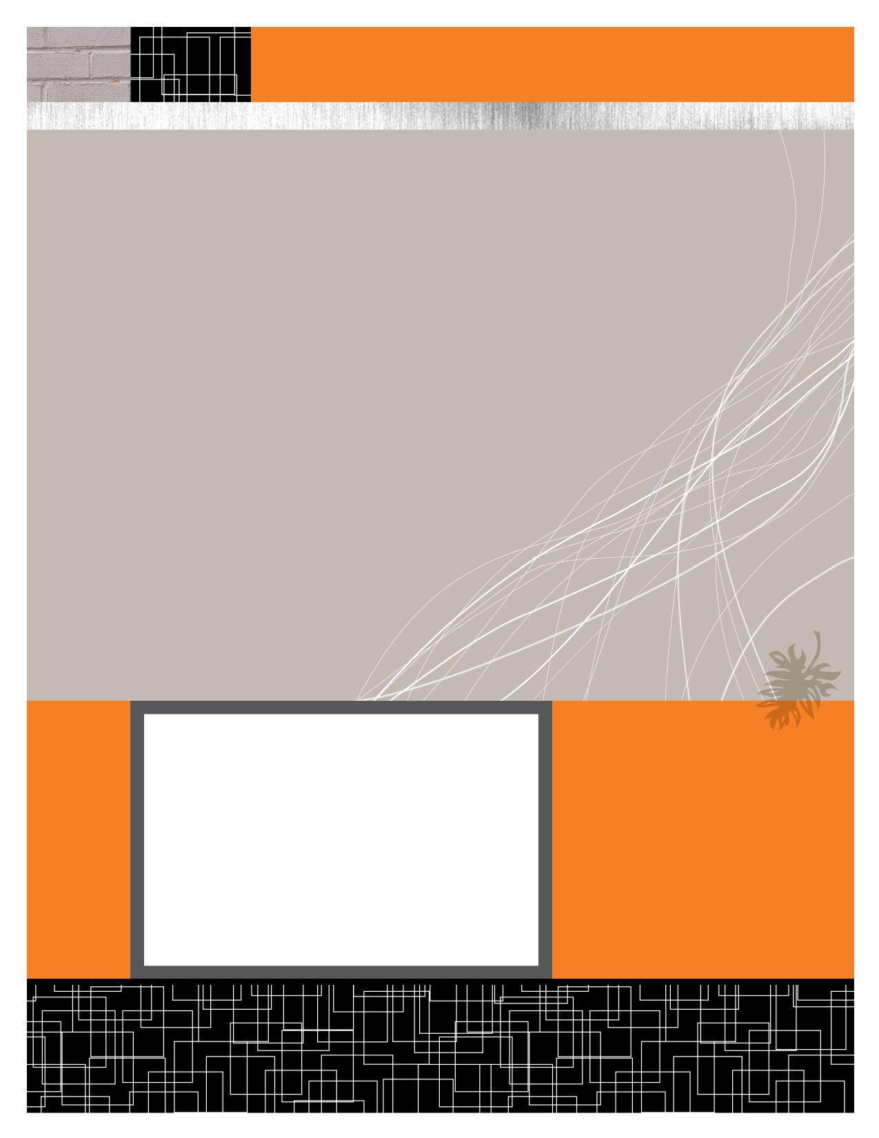

Anshul Jain (Y09UC027)

Mumal Seth (Y09UC086)

Shreya Mundra (Y09UC150)

Karan Poddar (Y09UC301)

Course Registration Portal

Data Store Description

February 22, 2012

|  |  |  |
| --- | --- | --- |
| DATA STORE | DATA ITEM | REMARKS |
| DS1 : Login Details | 1. Username  2. Password  3.Category(Dean/Professors/Students)  4.Physical Registered(Yes/No) | 1. The Login Details of Dean, Professors and Students all will be stored here.  2. It keeps a check of all those students who have registered themselves physically and will open the online registration portal for them **only**. |
| DS2 : Registration Details | 1.Students ID  2. Course ID  3. Type(Special/Overload/Normal)  4. Preference no. | 1. It stores the details of all the courses the student wants to opt for in the current semester |
| DS3 : Student Details | 1.Student ID  2.Course ID  3.Semester(Current/Previous) | This database stores the details of all the courses in which the student has been registered in current and all the previous semesters. |
| DS4 : Course Details | 1. Course Code  2.Name(Course Name)  3. Professor ID  4.No. of students allowed  5.Credits  6. Pre-requisites  7. Elective/Compulsory  8. Description  9. Stream_Year | It stores the course type (HSS/Science/Open) and other conditions necessary for registering in that course. |
| DS5 : Swap Courses | 1.Student ID_1  2.Student ID_2  3.Course ID_1  4. Course ID_2  5.Status(Approve/Reject) | If the student from whom the course has to be swapped (StudentID_2) accepts the request of the student(with StudentID_1) than the courses are swapped without the Dean permission. |
| DS6 : Applications | 1. Application ID  2.Student ID  3.Application Content  4.Status(Approve/Reject)  5.Type | This database stores the requests for different registration Types (repeat/overload/special) to be approved by the Dean. |
| DS7 : Event Schedule | 1. Event  2. Start Time  3. End Time | This database table stores when the registration/add/drop/swap starts and for how long it is active. |



DATA STORE DESCRIPTION